EC7212 – COMPUTER VISION AND IMAGE PROCESSING

TAKE HOME ASSIGNMENT 1

NAME : DIYUNUGALA D.T.N

REG No. : EG/2020/3918

SEMESTER: 07

DATE : 21/06/2025

GitHub code link: <https://github.com/TharukshiDiyunugala/ImageProcessing-Techniques-Python>

Original image used:

Figure : 736 x 491, 76.9 KB image sample

Q1.

Figure : Code for Q1

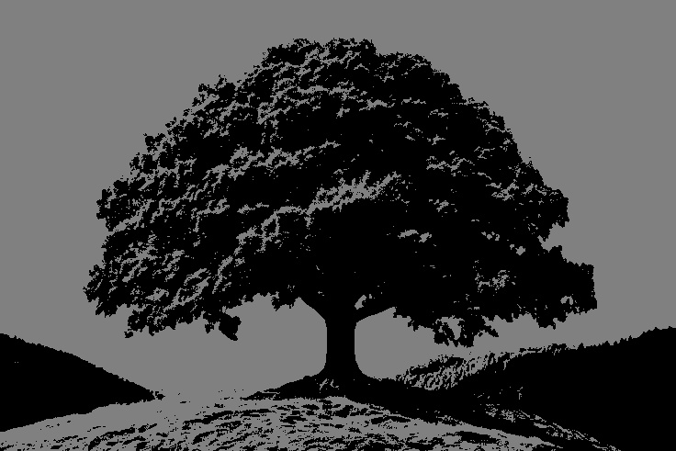

Figure : Output after reducing intensity levels to 2

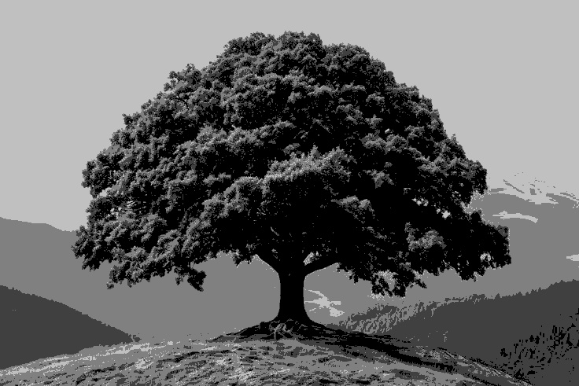

Figure : Output after reducing intensity levels to 4

Figure : Output after reducing intensity levels to 8

Figure : Output after reducing intensity levels to 16

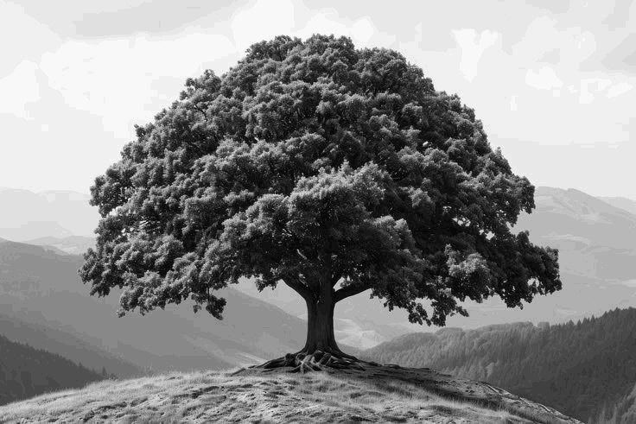

Figure : Output after reducing intensity levels to 32

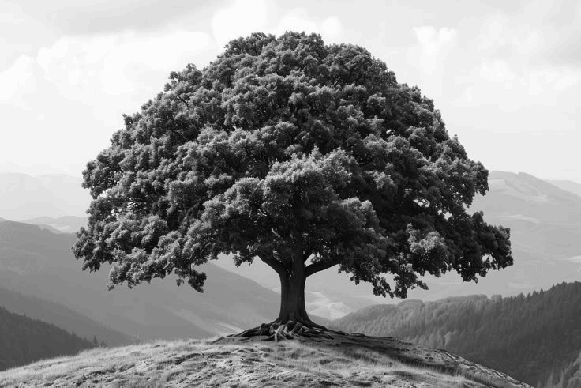

Figure : Output after reducing intensity levels to 64

Figure : Output after reducing intensity levels to 128

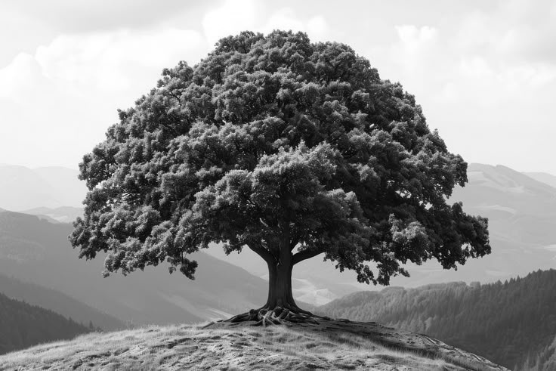

Figure : Output after reducing intensity levels to 256

Q2.

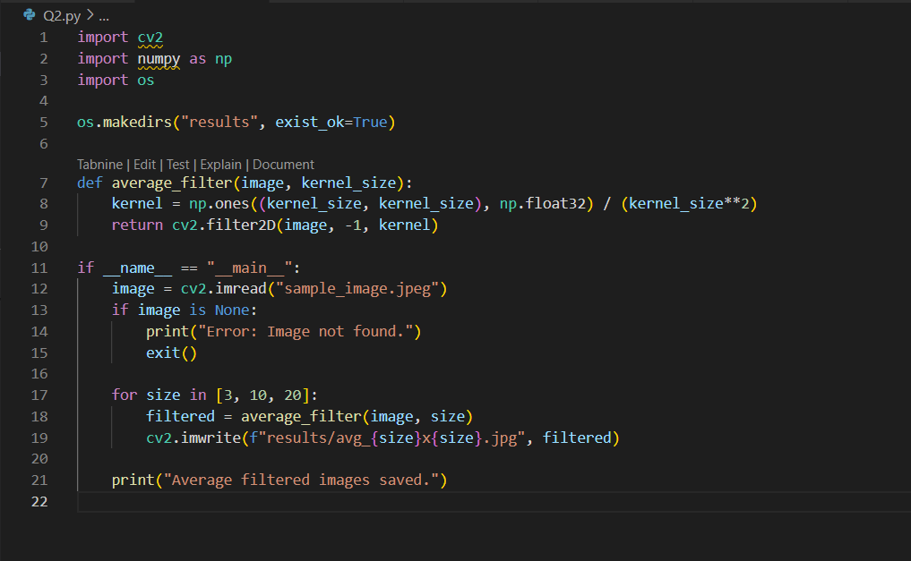

Figure : Code for Q2

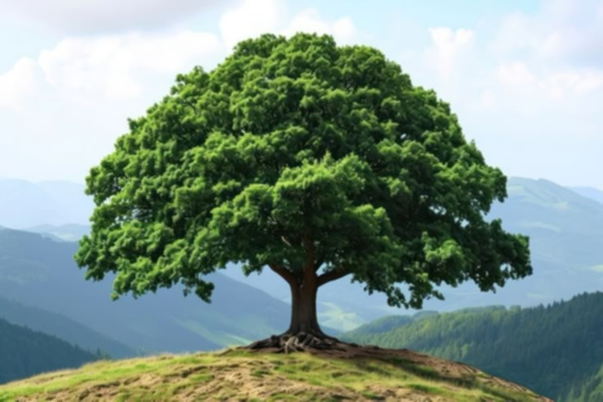

Figure : Image after applying 3×3 spatial averaging filter

Figure : Image after applying 10×10 spatial averaging filter

Figure : Image after applying 20×20 spatial averaging filter

Figure 13: Spatial 10x10 average

Q3.

Figure : Code for Q3

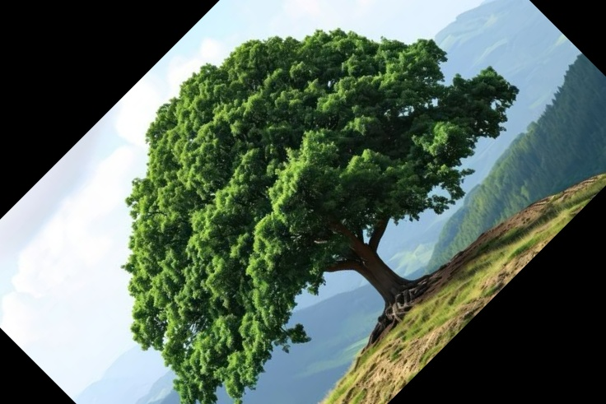

Figure : Image rotated by 45 degrees

Figure : Image rotated by 90 degrees

Q4.

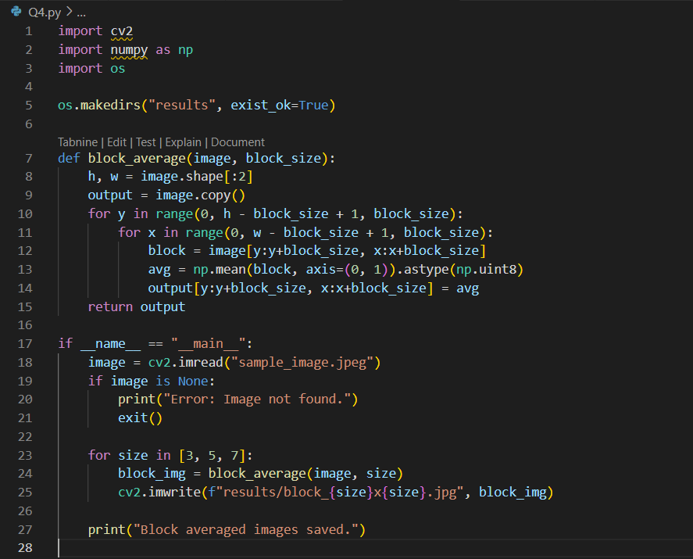

Figure : Code for Q4

Figure : Resolution reduced using 3×3 block averaging

Figure : Resolution reduced using 5 × 5 block averaging

Figure : Resolution reduced using 7×7 block averaging

Note: All the resultant images for the questions are included under the results folder inside the GitHub repository.